CSC 555 Software Engineering Midterm Individual Project
Gonuguntla Dinesh-918700
In this midterm Project, I will discuss the positives and negatives of the topics like Personal software process, Extreme Programming, and Scrum which professor had discussed in the class. Later I will give the broad overview of my company and the software’s which my organization wants to develop. I will elaborate on the challenges which my organization had faced while developing and testing this software.
Personal Software Process delivers engineers a controlled personal framework for doing software work. The PSP process consists of a set of methods, forms, and scripts that show software engineers how to manage the quality of their program, how to make commitments, how to improve estimation and planning and reduce the defects in their products. The PSP introduced both textbook and a course that is designed especially for industrial and academic use. It’s designed for use with any programming language, and it can be used for most aspects of software work, includes writing requirements and defining processes, running tests and repairing defects. When software engineers use the PSP, the recommended aim is to produce zero-defect products on schedule and within planned costs. PSP is all about what you (personally) do when designing and building software. If you are just a one-person software company use the PSP, you will save a lot of time. The team software process is all about running and organizing teams of PSP- trained engineers.
The principles of PSP are: individuals should be able to plan, deliver, monitor and improve the quality and timeliness of their own work. Use data to defensibly disapprove unreasonable demands. Say Yes with confidence and No with data and options. Learn from experience use the data from one piece of work to improve the next.
The model framework activities in PSP are the first thing is we must plan the project that means the size of the project and the resources that we use in this project and the defects and cost estimation everything will be included in the planning. The second one is a high-level design that means they consider the external specifications of all the components and all issues are recorded and tracked with the help of this. It’s more like the formal design and making design documents. Not only internal and external specifications and the external issues while there will occur when there are designing or tracking. The third one is high-level design review which are just like formal verifications to uncover the errors in high-level design that are uncovered. The next one is development, in this all the important tasks and the results would be maintained in the development that includes testing and compiles. The last one is postmortem, it is using the measures and metrics collected effectiveness of the process is determined and improved, Basically, it’s a final output.
We need to create the plan summary sheet which will summarize the all the work that we have done during the project. The plan summary sheets had Time in Phase (it will summarize the time that you have spent in the development phases).
Defects injected (you need to keep track of how many defects that you have injected in each phase). Defects Removed (how many defects that you have fixed in each phase while testing). Time log (it shows you how much time you spent in each phase). This summary sheet will help you to find out where your strength and weakness are.
Extreme programming is a software development methodology is to improve software quality it’s a short development lifecycle to increment and improve productivity for the customer requirements.
Extreme programming prioritizes coding the most important coding first. This allows the project to be stopped at any time yet still be at a useful state. The pair programming often associated with XP it can lead to increase creativity, two people are better than one and increased focus on the task at hand with someone next to you, you are less likely to take breaks, check email or other stuff. But pairing should be made with care. Being agile requires a lot of overhead. While it’s possible that changes can be made at some lower costs than the so-called waterfall model, the saving can be eaten up by the cost of planning and replanning. There is no reason why a project with traditional up-front cannot code the most important features first and the less important features cans still be dealmakers and breakers.
Unit testing which can miss design flaws is made more effective through pair programming. Pair programmers look to the on-site customers for specifications. The on-site customer is necessary because there are no detailed written requirements
The strengths of XP are it eliminate the Big design up front, you code the most important things first, you are positioned to be responsive to change, and the pair programming often associated with XP increase creativity and task focus. By eliminating big design up front extreme programming is very attractive to design extreme. Teams can get to develop code sooner, which can be gratifying to customers and managers who measure progress in terms of code. The weakness in XP is, you eliminate big design up front, it’s easy to forget how good design can pay for itself. It’s a requires a lot of overhead, the order of importance is subjective and can still be addressed by up-front design anyway, XP emphasizes teamwork, communication, prioritizing, but that’s because everything becomes harder and we need all that stuff even more. Each rule of XP only works when it is supported by some other rule.
Scrum is a lightweight, simple to understand (but difficult to master) agile process framework. Scrum is one of several agile software development methods. Scrum and Extreme programming are probably the two best-known agile methods. Extreme Programming emphasizes technical practices such as pair programming and continuous integration. Scrum emphasizes management practice such as the role of scrum master. Many companies use the management practices of the scrum with the technical practices of extreme programming. Scrum Is agile.
Almost 55 percent of organizations adopted Scrum. There are 3 pillars of scrum First one is Transparency: All relative aspects of the process must be visible to those responsible for the outcome. Inspection: There is a frequent inspection of the artifacts and progress to identify and correct undesirable variances. These occur during the sprint planning meeting, daily scrum, sprint review, and sprint retrospective. Adaptation: After inspection, adjustments should be made to the process and artifacts to minimize further deviation.
There are five core values of Scrum. Commitment: when we as a team value the commitment, we make to ourselves and our teammates, we are more likely to give our all to meet our goals. Focus: When we value focus and devote the whole of our attention to only a few things at once, we deliver a better-quality product faster. Openness: when we value being open with our teammates and ourselves, we feel comfortable inspecting our behavior and practices, we can adapt them accordingly. Respect: when we value respect, people feel safe to voice concerns and discuss issues, knowing that their voices are heard and valued. Courage: when we value courage, people are encouraged to step outside of their comfort zones and take on greater challenges, knowing that they will not be punished if they fail. Scrum master has some responsibilities such as coach team members, manage conflict, facilitate decision making, remove team impediments, increase organizational awareness of Scrum.
The scrum team has typically 6 (plus or minus 3) people. Teams are self-organizing and are cross-functional (Programmers, testers, user experience, designers etc.). Members should be full time. Maybe exceptions like database administrator. Membership should change only between sprints. In traditional team’s project manager is the team lead whereas in Scrum agile teams all are self-organizing.
Scrum has Sprint planning one hour per week of the sprint on requirements & designs. Each sprint has typically 1-4 weeks. There is a 15minutes daily scrum meeting. 2 hours per week for Backlog Refinement. One hour per week for Sprint Review. Three hours for Sprint Retrospective.
Scrum has daily meetings on every day at the same time. It helps to avoid unnecessary meetings. Only team members and scrum master can talk. Everyone who there in the scrum are basically has three questions like, what did you do yesterday. What will you do today? Is anything in your way.
Scrum is Easy because there is less minimal process overhead, Less bureaucracy, Less documentation, and Fewer surprises. It’s hard because of the change in processes, change in bureaucracy, changes in documentation standards and different kinds of surprises.
To overcome the slowness and adapting to frequent changes in developing a software a new methodology came into existence and named as agile. Agile methodology deals with these things. Communication or interactions over the developing software/people involved through various processes and tools. Gives more importance on the actual software or product going to be delivered instead of documenting the procedures followed.
Adapting to the frequenting changes that are proposed by the customer through planning daily. It works on a value-driven approach providing incremental delivery on weekly basis and responsive to the frequent changes which lead to customer satisfaction.
The advantages of the agile methodology are High revenue income due to faster and high-quality delivery. Mitigation of risk amount is less due to frequent interactions. Informal inspection at various intervals leads to proper shape and idea about the quality. Product delivery is an incremental way leads to more customer satisfaction.
Flavors in Agile Methodology: Agile generally doesn’t follow any concrete steps or methods to build a framework or project. To overcome these failures, it borrowed many principles from lean manufactures and created on the agile manifesto. There are some few methods generally an organization chooses to carry forward the Agile movement that includes Scrum, Kanban, Extreme Programming, Crystal Clear. In the above slides, we discussed the Scrum and Extreme Programming. Kanban gives the complete organization of workflow structure like maintaining visualization, setting up various limits, and providing proper details related to workflow. It works mainly on the workflow structure. Crystal Clear: As the name indicates it mainly focus on people, artifacts, easy access through frequent integration
When to use Agile: Large application? if so, it can be split into smaller deliverables. If the project really time constrained? If it isn’t there is no need to compromise deliverables or features everything must be delivered. Requirements flexible and defined only at a high level? Complete understanding of all deliverables. Only if customers are and can be available.
Agile will found the issues fast and efficiently. Agile main footnote is simple but changes everything. Time containers are short but easy to measure progress and expose issues.
The software that I would like to promote to my company (West Chester University) is Phone Earn. The main aim of the project is to reduce the students spending time on mobile phones. According to the survey conducted by many organizations, on an average, students are spending almost 4 to 5 hours a day on mobile phones by surfing social networking sites like Facebook, YouTube, Twitter, Netflix etc. If we can take 4 hours a day that is almost 20 hours per week and 120 hours per month i.e. 1,460 hours per year. Students are spending almost 2 months on one year of their time on mobile phones. If we can convert to money, then it’s almost 11,600 dollars per year are wasting by using the mobile phones.
First, I will discuss How these works by the end user (In this scenario its students) Later I will jump into the development of this project.
- All over the campus, we are inserting drop boxes which have a capacity of 10 phones*.
- Students will earn points depends on the time how much they kept their phone in the drop box.
- Assume 24 hours is one point. If a student earns 150 points, we will provide gift cards or free Parking pass or 5 free movie tickets in University treater and Sykes.
- A student can able to earn only when he/she drops their phone on more than 6 hours. Otherwise, a student doesn’t credit any points.
- The student must swipe, to drop a phone on the drop box.
- Each student ID card can accept only one Mobile phone.
- The reason why we kept the capacity of Dropbox is 10 phones are:
  - The students had to select how many phones they are dropping in the drop box.
  - If they are dropping 5 phones, then they had to select a 5 option and swipe all the 5 student ID cards whose mobile phones are dropping.
  - Like these pairs, they can earn more points. For e.g., if 2 pairs of students are dropping then they can earn 3 points. If 10 Students means they can earn 20 points on each.
  - If they want to credit the points on pairs they must do these on any 10 days in one semester otherwise you don’t earn.
- We are placing the drop boxes in a secure and surveillance location so that we can assure your mobile phones.
- Students can able to check their phone on the university website through the link which we design. Through these, you can check whether your phone is there in the box or not through video cam which every box had.
- As of now we are implementing only swiping an ID card option. The later stage we will implement a Biometric and ID and Last Four Digits of SSN to give more security to your mobile phone.
For the development of this software I am using the Dot Net framework and the Agile environment and for testing, I am proposing the TOSCA tool which will automate the user stories in the less time compared to selenium or QTP. In Agile Environment, I am following these steps i.e. Requirement gathering, Sprint planning, Development, Testing, Accepted, Production Release. I want to implement the Behavior-driven development to bring all the teams under one umbrella. To give an error-free application to the end users we are doing Unit testing, Retesting, Functionality testing, Non- Functional testing we have Performance testing and security testing, Smoke testing, Regression testing, End-to-End testing.
I am using JIRA application to track all the user stories and test cases created and modified by the testing, development team and scrum master and the product owner. Let’s starts the development of the application. Initially, Product owner has the complete authorization of the sprint like creating requirements, user stories, deciding on the priorities, product backlog, reviews, and even sprint can be canceled if something goes obsolete in the sprint.
Some Companies product owner will take care of the scrum team, but other companies’ business will be the main person for the scrum team. Here for our development, Business Analyst will be communicating with product owner about the requirements. Sometimes Business Analyst may ask the development team and Testing team to join along with him for the discussion of requirements with the product owner.
Behavior Driven Development (BDD) is a synthesis and refinement of practices from Test Driven Development (TDD) and Acceptance Test Driven Development (ATDD). BDD is all about collaboration and communication. Tests are written in a non-technical language that everyone can understand.
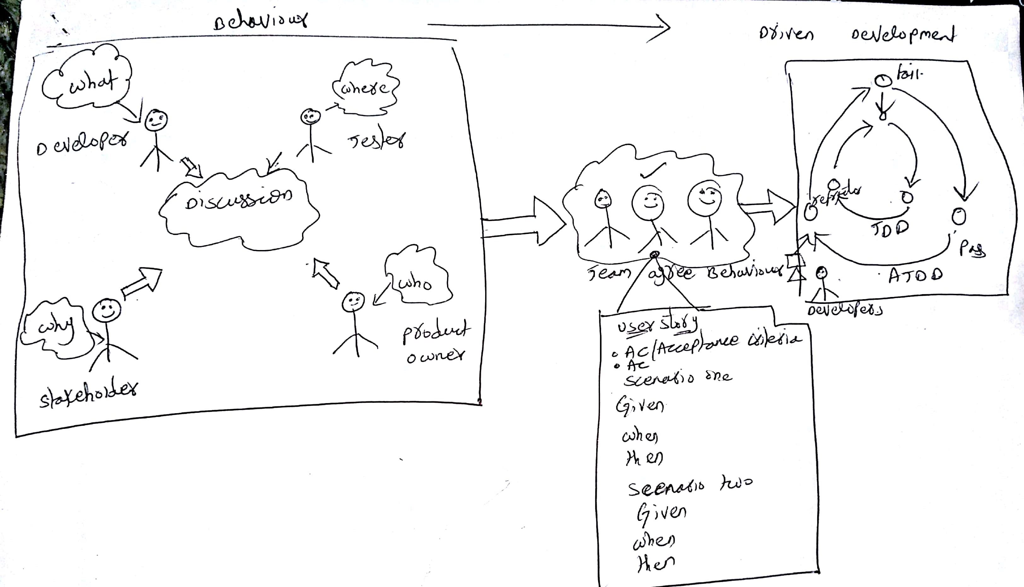

Behavior Driven Development is Building right thing, Fast feedback cycle, Living Documentation, Automated Acceptance Tests, Team Collaboration, Shared Understanding by discussing examples.
In behavior Developer, Tester, Stakeholder, Product Owner will all collaborate to discuss the user stories and requirements. Business Analyst has an authority to create the user stories. After discussion business analyst will then create the user stories and assign the points to each story according to the difficulty level. Mainly they will use 3, 6, 9,12. The easiest one will get the low points that are 3 and the difficulty one is 12. After the creation of user stories, they should write the Acceptance Criteria. The Acceptance Criteria has three things to write namely Given,
when, Then. The Acceptance Criteria will mainly useful for Dev team and testing team to check whether they had implemented and tested correctly or not.
Once the Business Analyst complete to write all the Acceptance Criteria’s, Requirements for the user story then he will change the User Story status to In Dev. If the dev team completes implementing the user story, then they must change the user story status In QA or they will deploy the completed user stories to in QA.
Quality Assurance team will write the test cases to each of the user stories which dev team has deployed in QA. Testing team will test all the user stories, if all the Acceptance Criteria passes means they will close those User stories, it doesn’t they will create the Bug for that user story and sent back to Dev team to fix that Bug then attached to the same user story which they found the bug while testing. To test all the User Stories, we used Tricentis TOSCA Automation tool which is like Selenium, UFT/QTP But Tosca has a less code to write. First, we need to scan the Page which you want to automate, Tosca will automatically capture all the buttons which there on the scan page. After that you must select the functionalities which you need to automate. Write the logics if you required. Then run the program through. By using tosca you are saving a lot more time than selenium. But tosca is not an open source tool that’s the main reason so many organizations are not preferring these instead they are going to selenium.
Once the testing of all the user stories completed they will do the Regression testing (Testing of all the functionalities including one to major defects fixed), End-End-Testing (Checking whether the functionalities with related test data is flowing or not), Smoke Testing (The main functionalities of the application. In other words, Happy Path), Resting (Testing of all the fixed defects to make sure whether the corrected functionalities or working or not). Once all these processes of testing completed they will deploy to production. The production team and the development team together deploy all the Sprint User stories to live.

There is a Data Base administrator in each phase of the project. The main work that he will do is update the tables, Load the tables with the data provided by either the testing team or Dev team.
The tools that basically Behavior Driven Development used are:
 | JAVA | Dot Net
IDE | Eclipse | Visual Studio
BDD Interpreter | Cucumber | Spec Flow
Automation | WebDriver/Selenium | WebDriver/Selenium
Testing Framework | Junit/TestNG | NUnit
Reporting | Extent Reports etc.

The workflow of the Behavior Driven Development:
1. Write User Stories and Acceptance Criteria.
2. Write feature files in Gherkin (Given, When, Then) language.
3. Write scenarios under the selected feature.
4. Write step definitions for each scenario
5. Generate Skelton code-based scenario.
6. Run feature files and fail it.
7. Write Automation code to make step pass.
8. Refactor code, Clean code, Create reusable automation library.
9. Run features and pass.
These are steps that involve in the creation of software through Behavior Driven Development using Agile methodology.
The Approach of the Behavior Driven Development:
Initially, all User Stories are present in Backlog, Once the Sprint starts Business Analyst will move that User Stories to Current Sprint. The Business Analyst will write the Acceptance Criteria and Quality Assurance Testing team, or BA will write the Feature files in Gherkin. This all done before Sprint. During the sprint, we execute the feature files, step definition generation, and automation code. Then Application script development happens and will execute the script and will get the test results.

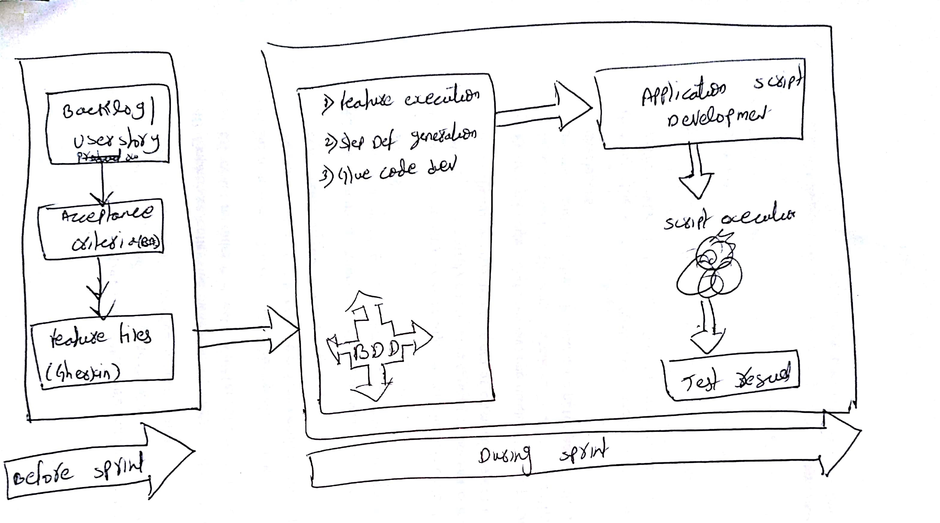
Some of the User Stories which are there in my Current sprint plan.
User Story: As an admin, I want to know how many students have used these services in a day or in one semester.
User Story: System should not give, access to unauthorized Id cards.
User Story: System should be easy to maintain and install.
User Story: System verification should be completed in less than 25 seconds
User Story: System cannot accept more than ten student id cards.
User Story: System should send information to the safety department if someone tries to open a drop box unauthorizedly.
User story (Backlog): The card reader with an integrated scanner will capture a biometric from the person and compare it with the existing template on the card and in the database.

The challenges which may programmers face during the implementation of Behavior Driven Development through Agile Methodology is.
- Initially people may have confused between the Behavior Driven Development, Agile Scrum.
- Most of the programmers may worried about these major changes, that’s why I taught I want to implement this, within the 6 months of time on step by step.
- After use of these Behavior Driven Development maybe we will get a positive review from all the testers, developers.

Bibliography:
1.Personal Software Process by Watts S. Humphrey.
2. Infosys Limited Reference Papers.

